Algebra 1: Unit 5, Lesson 6

- Rewrite the equation, $4x-5y=20$, in slope-intercept form by isolating the variable, $y$. Write all fractions with no common factors.

$$y=\frac{4}{5}x-4$$

- The linear equations, $y=\frac{5}{3}x+2$ and $y=\frac{5}{3}x-7$ are ______________ line.

parallel

- The graph of the equation, $y=\frac{2}{3}x+2$ is shown.
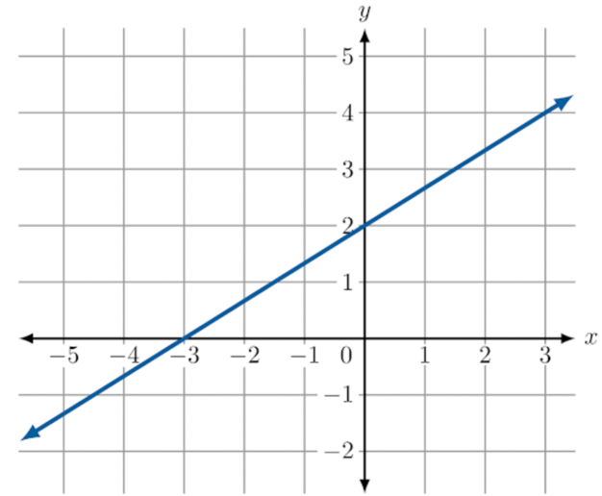
The coordinate $(9, _____)$ lies on the line and is a solution to the equation that represents the line.
$$8$$

